**Lesson 8 Demo 7**

**How to Use Normal Distribution**



**Steps to be followed:**

**Step 1: Open the Excel file**

* 1. Open the file named **Data.xlsx**, worksheet **Normal Distribution**

**Step 2: Normal Distribution**

2.1 Check if data in column B is available

2.2 Find the mean and standard distribution of this data

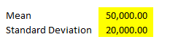

2.3 Create a function as below in column D

2.4 Choose Smooth scatter plot from Insert tab as below

2.5 Choose the chart data as B8:C89

2.6 The resulting chart will look like this

